# CS 255 System Design Document

## UML Diagrams

### UML Use Case Diagram

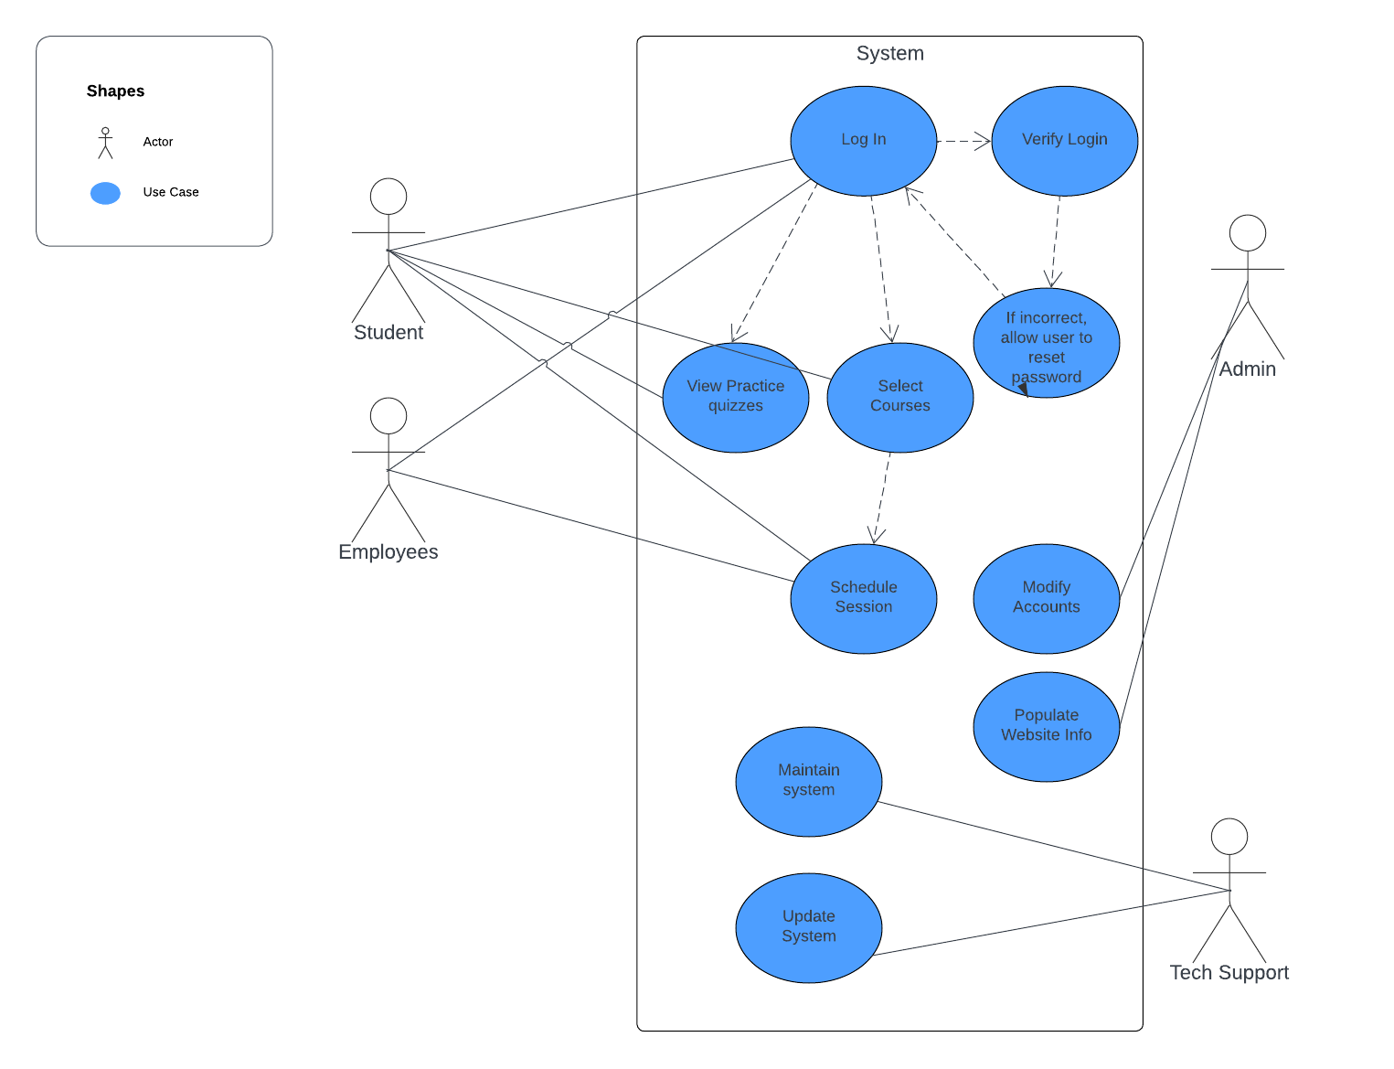

### UML Activity Diagrams

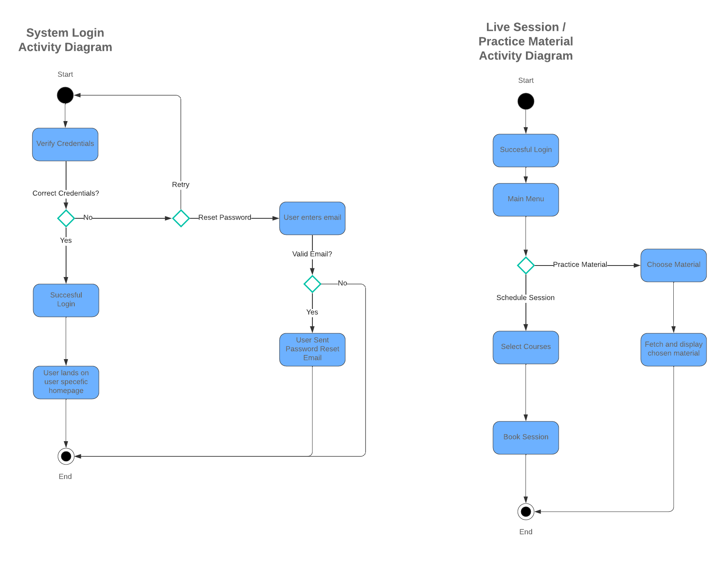

### UML Sequence Diagram

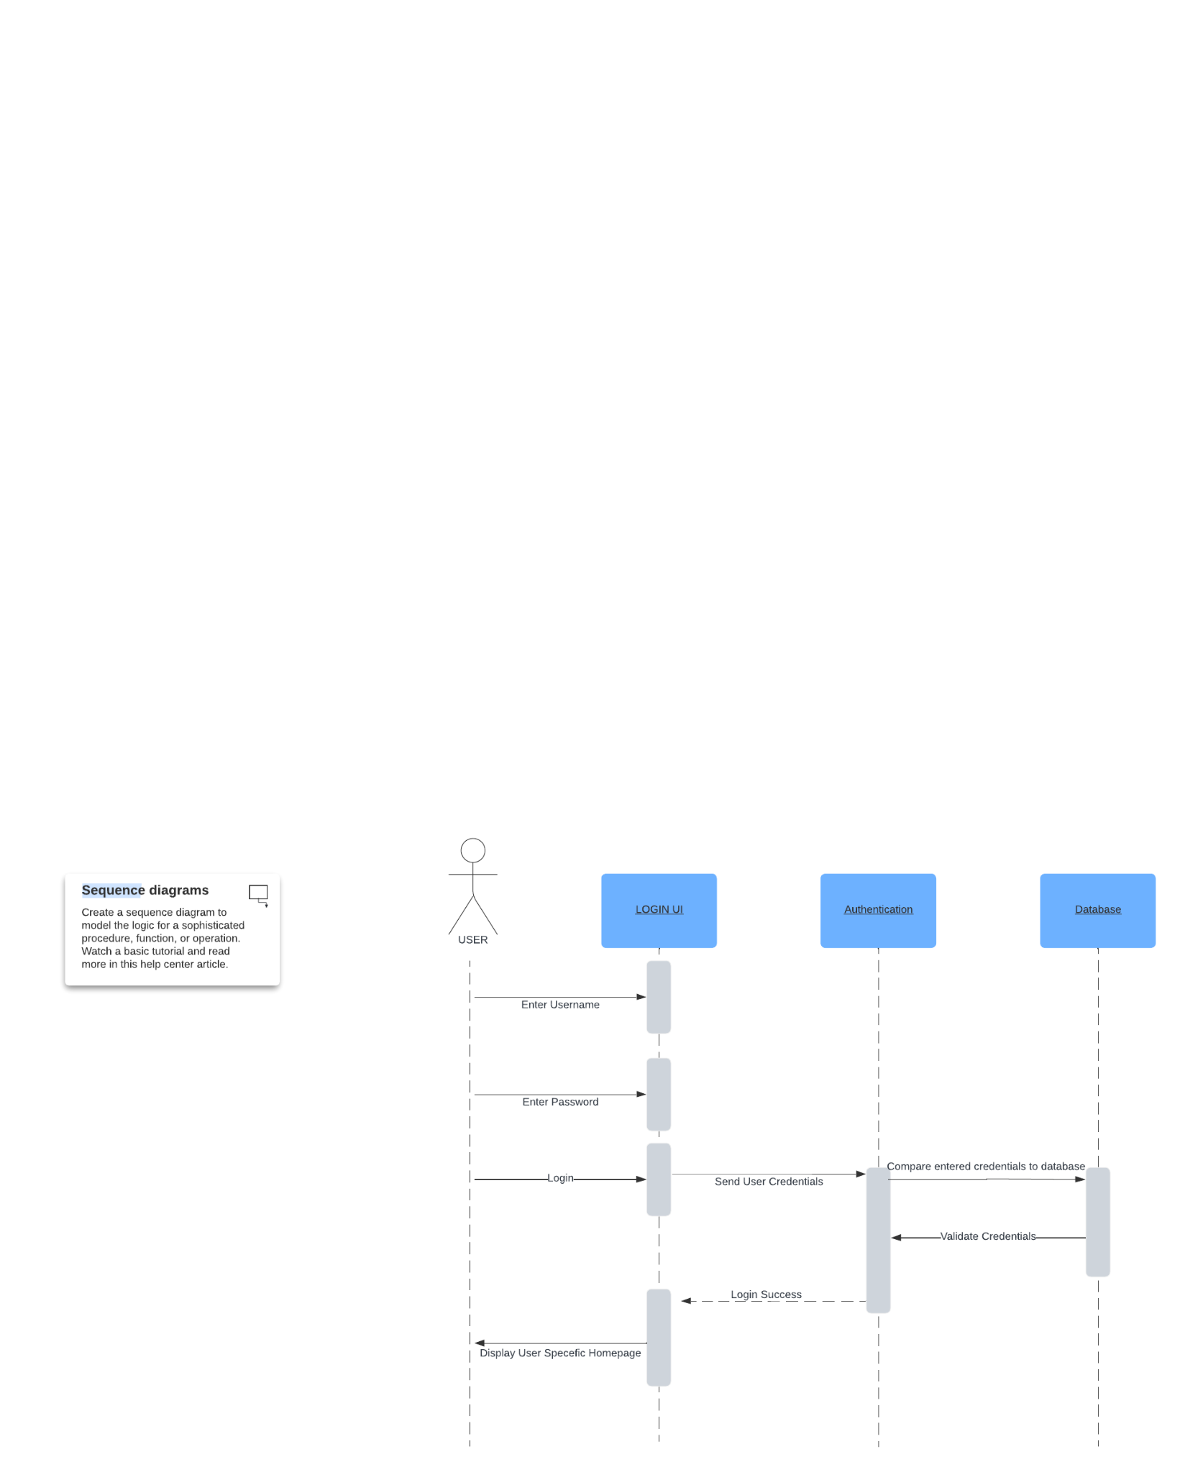

### UML Class Diagram

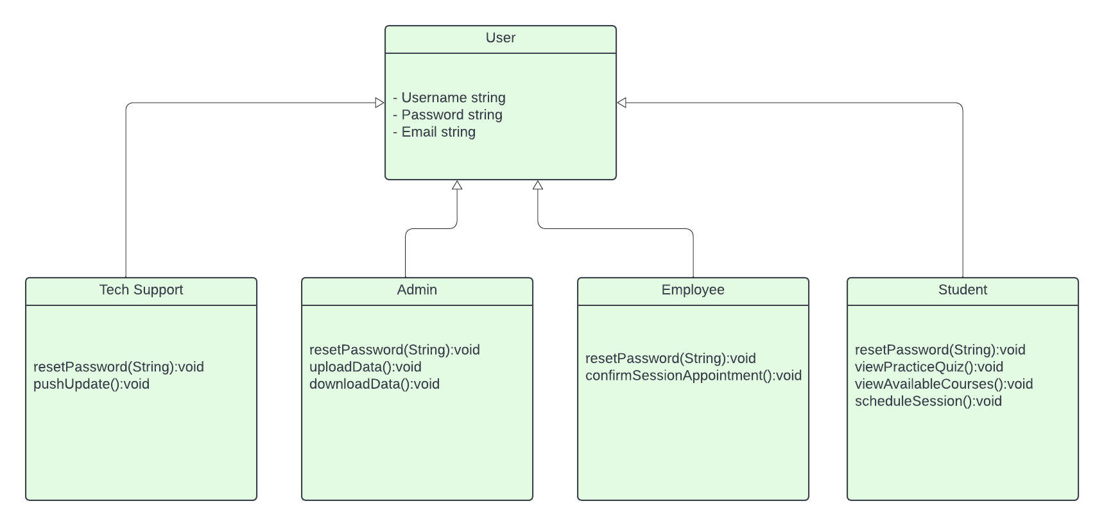

## Technical Requirements

The system needs to be online (cloud) based. This allows the system to be accessed from any device. Additionally, the system will need a database to store the user information as well as course materials etc. Since we will be storing customer information, it will also be important to incorporate a form of encryption to protect the data. Also, multiple different classes of users will need to be created. A base (student) user who can have access to their materials and schedule sessions. A Teacher user who can confirm appointments. An admin user who oversees the content and general day to day system functions. Lastly, a tech support team who maintains the system and keeps the system updated and secure.